Name: _________________________________________
SCREEN TIME TRACKING P1-3 Example

Day of the week | SCREEN TIME: TV, Gaming,  Surfing the net, iPad, Laptop, Smartphone etc. | How many times in the last 24 hours at home for entertainment has your child watched: TV and used the laptop, smart phone, iPad, computer
Monday

Wednesday

Saturday

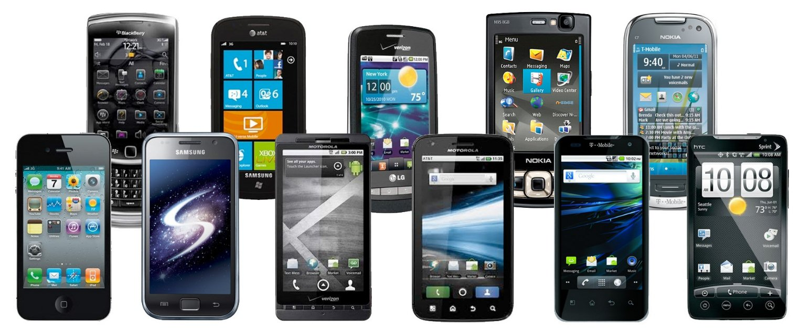
Comment:

Are you surprised by the results? Yes or no

Do you think the results are a concern? Why or why not?

What do you think you should do now?

