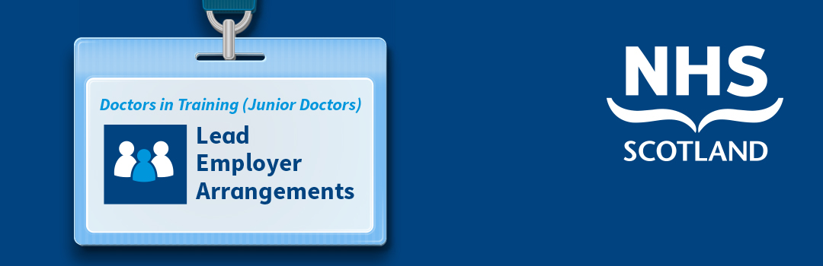
Dear Doctor in Training
Welcome to Turas People. Turas People is a new application hosted on the Turas platform that will support implementation of the lead employer model. You will now see a Turas People tile, alongside other applications such as TPM and eportfolio, when you log into Turas.
https://turaspeople.nes.nhs.scot

The following information is important as it provides essential information to enable you to complete the process of employment for your training programme.
Lead employer
From August 2018, NHS Scotland is moving from 22 Health Board employers to just 4 lead employers for doctors in training: NHS Grampian for the North region, NHS Lothian for the East region, NHS Greater Glasgow and Clyde for the West region and NHS Education for Scotland (NES) for all GP trainees, with the 3 other lead employers covering the other specialties and foundation trainees on a regional basis. The national programmes will be distributed across the lead employers, so that trainees on these programmes will also benefit from a single employer for the duration of their programme. The other Boards will continue to host trainees on placement as part of the training programme, they will be known as ‘placement Boards’. Whilst the employing Boards will have employment responsibilities, the placement Boards will continue to have clinical governance responsibility for those engaged in providing clinical care to placement Board patients. The lead employer model has been developed in partnership with the British Medical Association.
New and existing trainees will begin transitioning onto the lead employer arrangements from April. To support this work the Turas platform has been extended to include Turas People, an application that will assist medical staffing/ HR colleagues in employment related workflows, facilitating the provision of information between trainees, placement Boards and employing Boards, reducing duplication across systems and assisting in ensuring that the trainees get paid accurately.
We hope these changes will improve the doctor in training employment journey as follows:
- less employment related administration and duplication of information provided;
- a single contract of employment for the duration of a programme;
- reduced tax issues;
- continuous service with one employer making it easier for you to access employee benefits; and
- clearer employment arrangements for money lenders (e.g. mortgages/ cars/ credit rating).
A set of FAQs with detail on the lead employer arrangements can be accessed here.
Benefits of Turas People
Turas People will be used by doctors in training and medical staffing/ HR Departments in boards to share information on the placement and employment of doctors in Boards. Information provided at recruitment and programme allocation information will feed into Turas People to assist in the pre-employment checks required for you to commence or continue your employment with one of the employing Boards for the duration of your training programme.
From Turas People you will be able to:
- receive an offer of employment letter from the lead employer for your programme of training;
- provide pre-employment information such as references and right to work information not confirmed at recruitment;
- complete the staff engagement form to ensure you can get paid in August;
- complete pre-employment occupational health documentation, including provision of proof of immunisations and immunisation history;
- track progress with pre-employment checks;
- receive alerts on any actions you are required to progress;
- receive, sign and store your contract of employment;
- access, complete, submit and save forms you may require to complete during your employment (e.g. parental leave forms, maternity paperwork);
- receive, sign and store amendments to your contract of employment;
- receive information on your next Placement, and
- upload useful documents to your filing cabinet.
You told us that it can be hard to keep track of the multiple documents you require during employment, so we think Turas People will assist in making your employment journey more straightforward and provide a central place for you to access, receive and store employment related information.
We understand that many of you may take some time out between programmes, the Turas platform is cloud based, this means that you will be able to access your employment related information stored on Turas People wherever you are and from multiple devices. In addition, before you head off on any exciting travels you can upload useful documents to your filing cabinet in advance as these may be required by your prospective employer (e.g. payslips, evidence of right to work, competences, immunisation certificates).
Joining instructions
To benefit from this functionality, we are asking you to activate your account on Turas People. If you are already a user of the Turas platform, you will now see the Turas People tile on your dashboard when you login. If you are new to the Turas platform

https://turaspeople.nes.nhs.scot

Please note, you may find it beneficial to use an nhs.net email account for Turas People, as this will not change as you rotate through placements. In addition, it is our understanding that many of the Boards require doctors in training to have a nhs.net account in order to access online induction materials. Please see instructions for setting up a nhs.net account here.
What will happen next?
You will soon receive an offer letter from your employing Board for your programme of training with instructions detailing what you are required to do to complete the pre-employment checks and complete the information required for you to be added to payroll from 1st August 2018.
Updating your personal details
You must ensure that your personal information is updated on Turas People and any changes should be made by logging onto the Turas platform, selecting Dashboard (top of screen) and then by clicking on your name on the top right-hand corner and selecting ‘Personal Details’. This will update your details across all Turas applications.
PVG
NES is responsible for carrying out your criminal record check via the PVG scheme as NES is the single service provider for PVG checks for Doctors and Dentists in training (DDit) in NHS Scotland. You will be required to complete the PVG application prior to starting in post.
We will be sending you a PVG application early May 2018, this application will be sent to your home address which is currently recorded in Turas People. We would advise that you log in and check that this is still your current address. If not, please update this on the system no later than the 30th April 2018. For further information on the PVG process, please refer to our webpage or contact the NES PVG HR Team on PVG.HR@nes.scot.nhs.uk
Further information
Further information on the lead employer model and how this is being implemented across the employing Boards and placements is available here. You can also access the Data Sharing Agreement for further detail on how your data will be processed.

