Turas – Account Verification Process

- Once you have requested access to your Turas account and received a Reset Password Link through your email, please click on the link within that email and follow the steps below.

- You should be taken to the screen below. Please input your email address – this has to be exact. Once the email address is in, click on “Send Verification Code”
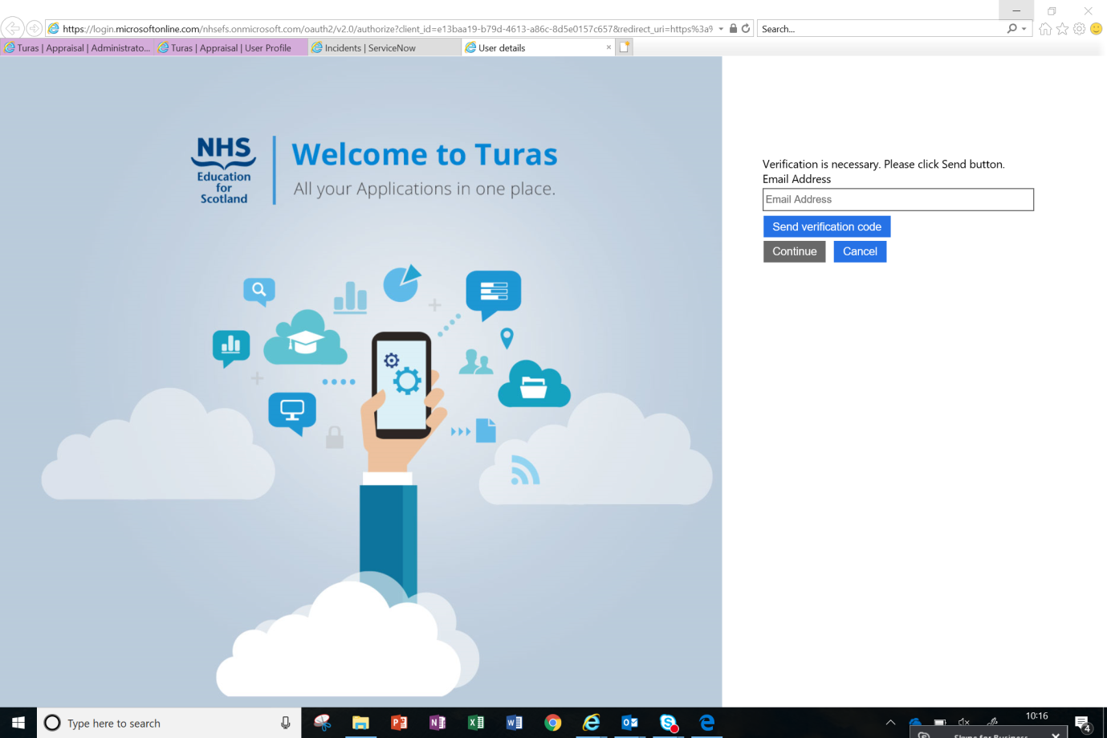

- You will now be taken to the screen below. In the meantime the system has sent you a verification code to the email you typed in. Please leave the Turas page opened, until the code arrives, as this is where you need to input it back for verification.

*Please note the code may take several minutes to arrive so don’t request another one if it doesn’t arrive straight away*
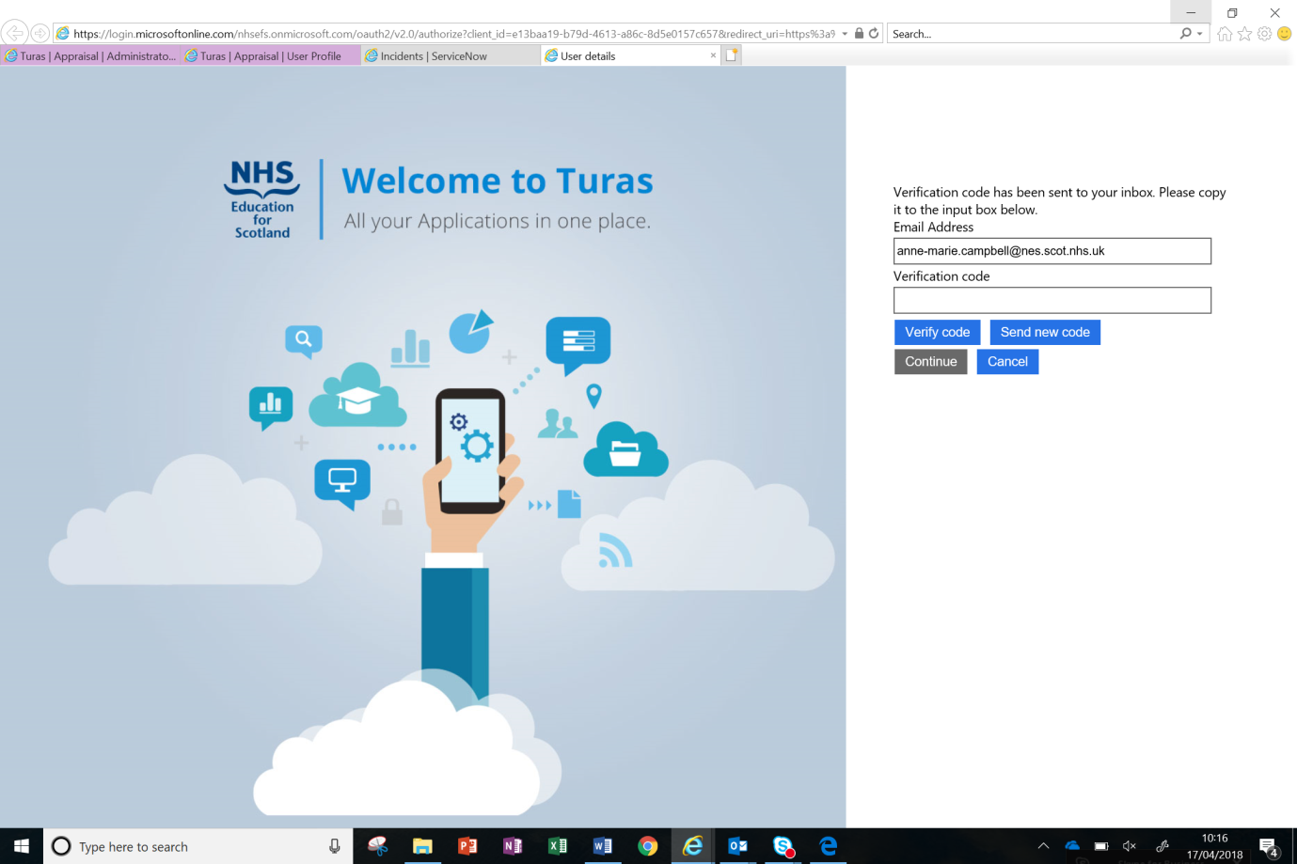

- Once the code arrives, input that in the “Verification code” field and click on “Verify code” then “Continue”. See example below.

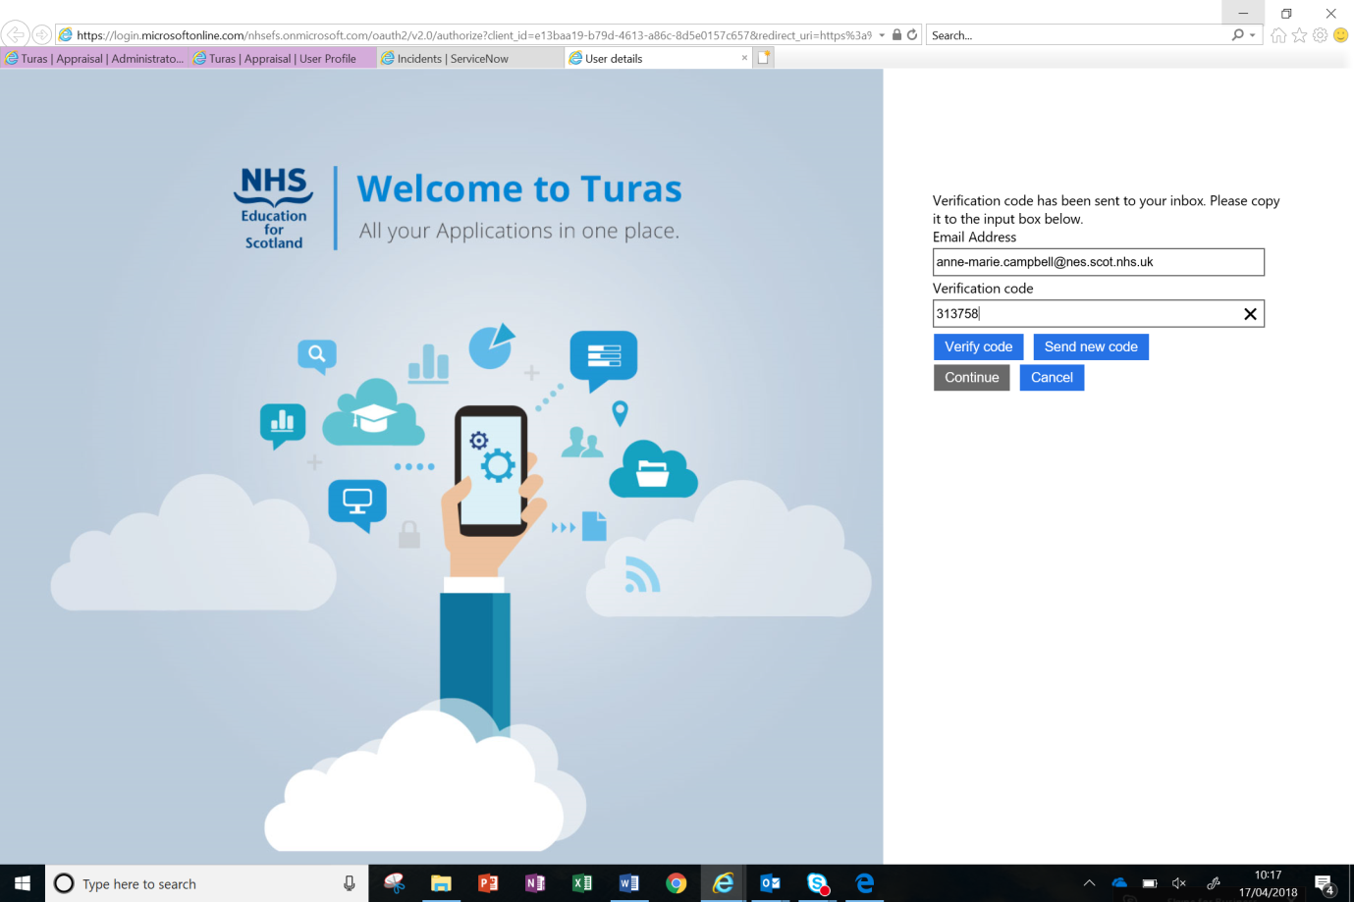

- You will be taken to a screen below. Please click “Continue”.
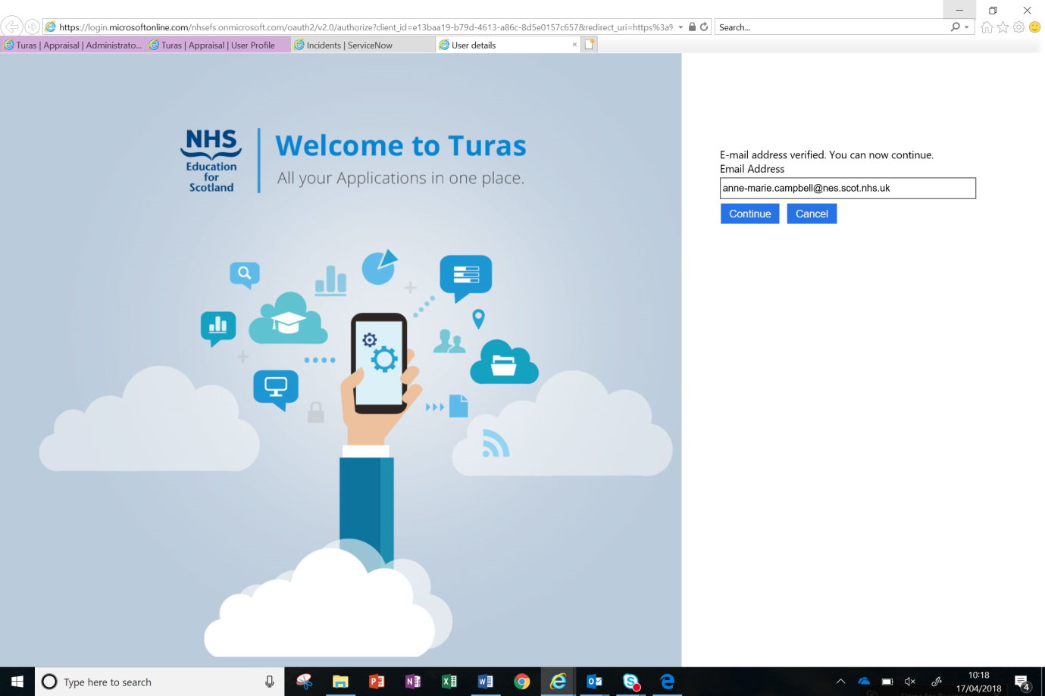

- The system will now let you create a new password. Think of a password that meets the following criteria:
- Is between 8-16 characters
- Has at least one upper case
- Has at least one lower case
- Has at least one number
Type your password in “New Password” and then repeat in “Confirm New Password”, then select continue.
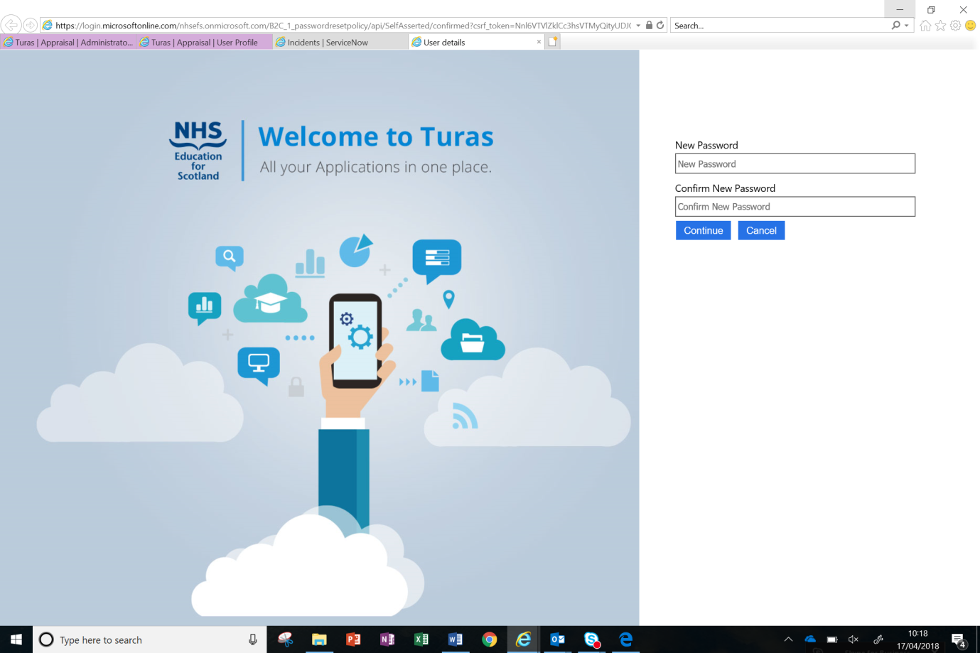

- That is you successfully registered now, you will be taken to the screen below. You can sign in as normal from now on. Please go to https://turasdashboard.nes.nhs.scot
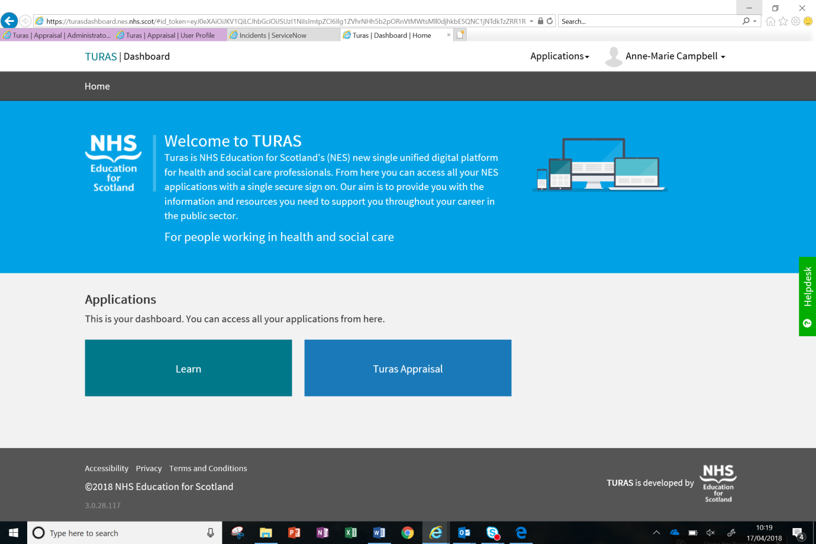

For any help please contact L&E Team on 0141 278 2700, Option 3 and at LE.Support@ggc.scot.nhs.uk

