Career and Development Planning Guidance

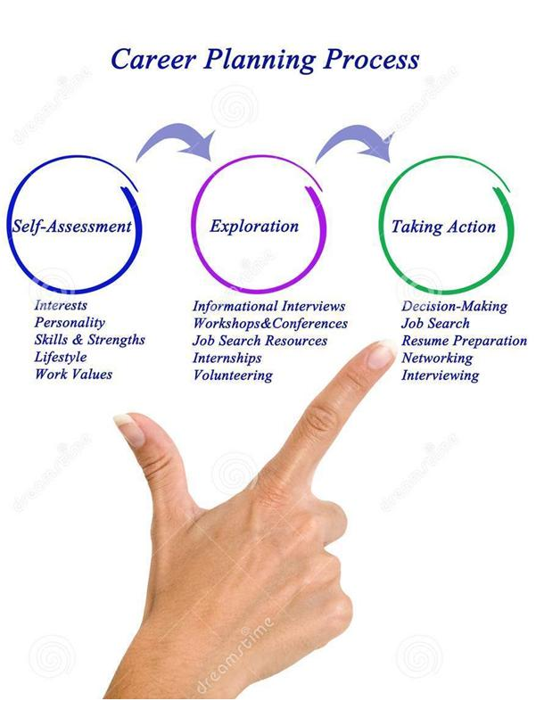

A Guide for Employees
Career and Development Planning Guidance

Managing Your Career

Keeping your skills and knowledge relevant and up to date is essential in the fast changing world of the NHS and especially so if you want to progress your career.

So... how do you manage your own career with confidence?

NHS Greater Glasgow and Clyde offers a wide range and variety of Learning, Development & Education options to support your personal growth and career planning. That you actively own and drive your own career development plan is core to being successful.

Taking control of your career development and progression will involve a combination of structured planning and active management of the learning choices you make.

The key to a successful career is being clear on what you want to achieve, having structured goals to do this and discussing these with your manager. Having your manager’s support and guidance will allow you to progress more easily, access the right learning opportunities and achieve the right experience to prepare for future roles.

Making a Career Plan

A career plan is the structured planning element of your career development and will be a list of the short and long term career goals you have and the actions you can take to achieve these.

Creating a career plan will help you think about and identify gaps in your learning and the decisions you need to make on the development activities you can undertake to fill these gaps – See Appendix A below.

There are 3 steps you should take to develop your plan ie Self-Assessment, Exploring Solutions and Taking Action.

Career and Development Planning Guidance
Stage 1: Self Assessment

This stage requires an analysis of you eg
- Your past roles, learning and experience
- Your current role, skills and knowledge
- What do you enjoy doing and want to do more of
- The things you do well and are natural strengths
- Your lifestyle and how you want your career to fit with this
- Your values and areas of interest
- Your motivation and the level of effort you are willing to make to develop further

Taking time to reflect and be clear on questions like these, prioritising what is most important to do you and what you do best will inform the type of career you wish to pursue. It may also help you to identify the types of roles that would not fit with your skills, interests or values.

At this stage your now have a solid platform to explore the posts you are interested in and consider how you can research and find out more about these:

Stage 2: Exploration

- What is involved in the careers or roles you are drawn towards – having more than one route to follow may be helpful
- Compare the strengths and skills you have identified with what is needed by the career you are interested in
- How transferrable are your current skills to the type of work you are interested in
- How much would these need to grow or develop
- Where are there gaps in your knowledge, skills or expertise
- What actions can you take to most effectively fill these and over how long
- What challenges are you likely to face and how do you plan to manage these
- How in demand are people for this type of role – are vacancies rare or is there a fairly wide and regular choice of posts
- Who can you talk with to find out more about a specific post
- How flexible are you in terms of location, shift patterns etc
Remember much of your learning may not be planned. Stage 2 is a guide but opportunities for learning may arise or your learning needs may change or grow as you move through the year. Your focus should be on the outcomes you would like to achieve and taking every opportunity to learn.
Career and Development Planning Guidance
Remember development will take many forms and may include:
- Formal Learning & Education courses
- Experiential learning e.g. shadowing or secondment
- Learning from others’ practice and experience e.g. mentoring
- As part of your post within the organisation or from another external source eg networking

It is important to take account of the skills and experience you gain every day at work. Make the most of day-to-day learning by taking the time to regularly reflect and apply this as much as you can in your current post.

Once you have decided on your future career direction and roles you should begin to set some goals to achieve developing the knowledge, skills or experience these will require.

How you achieve your development goals may vary – you may undertake formal education, hands on experience or self directed learning. It is important to create milestones to allow you review progress and make adjustments.

Step 3: Taking Action

Although you can develop your plan at any time during the year it makes sense to align this with your annual Personal Development Plan (PDP) discussion. Your annual PDP conversation is the structured opportunity you have to discuss your career aspirations with your line manager and agree the development activities you will undertake over the next twelve months. These can then be recorded on your development and career plans.

You should now:
- Set development goals and the actions you need to take to achieve these. Consider the short-term and longer-term goals you need to set as well as the smaller, easily achievable goals and the larger, longer term learning you wish to achieve. Consider the development approach that will work best for you. Consider the support you need to be able to successfully undertake this goal. Be clear on the outcomes you are planning to achieve and what successful delivery of these will look like.

Career and Development Planning Guidance

- Set some clear timeframes to achieve your goals. Setting deadlines for each of your goals will motivate you to get things done. Whether you work towards exact dates, or pick a broader timescale (e.g. a particular month) – adding these into your career plan or current PDP will give your goals some realistic context, an incentive to complete and opportunity to discuss further with your line manager. Larger learning goals may be broken down into delivery of milestones and associated outcomes for each.

- Review your goals and progress regularly. A career plan isn’t a one-stop-solution. To make sure your goals are up-to-date, it’s important to keep checking back on your career development plan. Not only will it allow you to track your progress, it’ll also mean you can make alterations if your circumstances change. Regular review will also allow you to surface barriers or challenges to achieving your career development goal and allow you to discuss this with our manager.

- Look for support from those who are able to help. You may wish to draw on the experience of others to support your career and development plan eg
  - A mentor who has undertaken a similar career path and can share their successes and experience
  - Someone effectively delivering the type of role you are moving towards who can share their knowledge on the less obvious skills and experiences that will help you towards this role
  - An OD or Learning and Educational professional who can advise on the best provisions to support your learning.

A template that you may find helpful is provided on the next page.

Career Development Plan opment Plan
Goal/s to be achieved:
COVERING THE PERIOD FROM: |  | TO:

Planned outcome. Where do I want to be by the end of this period? What do I want to be doing? (This may be evolutionary or “more of the same”.)
What do I want/need to learn? | What will I do to achieve this? | What resources or support will I need? | What will my success criteria be? | Target dates for review and completion

