Within this guidance document you will find guidance on the following activities where a person needs the assistance of a hoist. This guidance provides some of the many options available; it is not an exhaustive list of options.
If you require additional information or support, contact the Moving and Handling Department for advice. Clicking on the headings below will take you to the guidance for that activity:
- Types of hoists
1a) Passive sling lift hoists (mobile / overhead tracking (OHT) / gantry fitted)
1b) Active hoists (Standing aids)
1c) Seated bathing hoists

- Types of slings
2a) Fabric v Single Patient Use (disposable)
2b) Compatibility
2c) Sling Sizes
2d) Sling Styles

- Fitting a sling
3a) How to size a sling
3b) To a person in bed
3c) To a person sitting in a chair

- Hoisting Activities
4a) From Bed
4b) From Chair
4c) From Floor (available in separate guidance here)

- Overhead Tracking Hoists

1) Type of hoists
1a) Passive sling lift hoists (mobile, OHT or gantry fitted)
Passive hoisting systems allow for the transfer of people regardless of their level of mobility, some examples are provided below. For information on a particular hoist please click here.
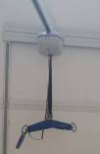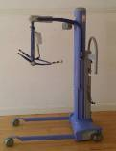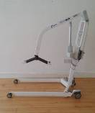

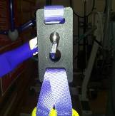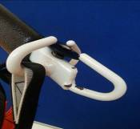Passive hoist sling attachment points can be either ‘clip’ or ‘loop’. Clip slings cannot be used on a loop attachment spreader bar and vice versa.
Clip
Loop

Passive hoists are used for the person with no weight bearing capability.
It is always a minimum of two people to assist when using passive hoists.

1b) Active Hoists
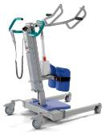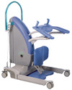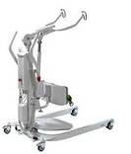Active hoist systems allow for the transfer of people who are able to weight bear but require additional assistance.

Active hoist attachment points can be either ‘clip’ or ‘loop’, with an exception being the Arjo Sara Plus (Encore) which uses a cord and toggle attachment
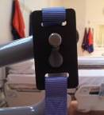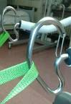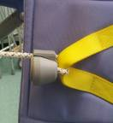
Clip
Loop
Cord and Toggle

Active hoists are used for a person who can weight bear although requires assistance to fully stand. The person must also be cognitively able to understand instructions, keep their feet on the footplate and hold onto the frame during transfer.
It is always a minimum of two people to assist when using this type of equipment.

1c) Seated bathing hoists
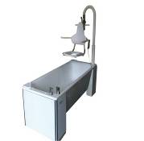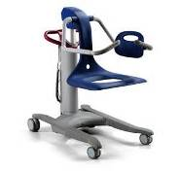Seated bathing hoists are used to assist people into and out of baths if they are unable to transfer independently or with minimal assistance.

Seated bathing hoists are used with a person who cannot step into or out of the bath independently or with minimal manual assistance.
The person must have the ability to sit upright on the hoist and be cognitively able to understand instructions.
It is always a minimum of two people to assist when using this type of equipment.

2) Types of Slings
Hoist slings are designed to lift people when attached to a compatible hoist. Slings can be either a standard general purpose type or designed to suit the needs of a specific group, for example, people with a lower limb amputation.
NB: Choosing the correct type of style and size of sling is crucial to achieving a safe and comfortable transfer experience for the person being hoisted

2a) Reusable v Disposable (Single Patient Use)
Reusable slings are for single person use and are required to be laundered in line with local infection control and laundry procedures prior to being used on any subsequent person.
Disposable slings are also single person use and can be used by the same person until they are no longer needed, the sling shows sign of wear and tear, or the sling becomes soiled. At this point the sling must be disposed of in line with local clinical waste disposal guidance.

Disposable slings must not be laundered. Disposable slings feature a wash indicator. If the sling is accidently laundered the wash indicator will fade and a warning label will be visible. If the warning label is visible the sling must not be used and must be disposed of immediately

2b) Compatibility
Slings are available with two types of connections Clip & Loop
i) Clip slings connect to a compatible passive or active hoist spreader bar.
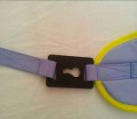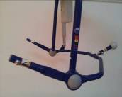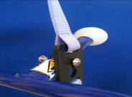
ii) Loop slings connect to a compatible passive or active hoist spreader bar.
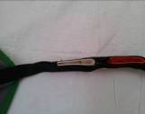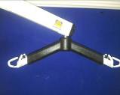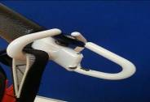
NB: Slings with loop attachments cannot be used on hoists with clip attachments and vice versa.
For further information see the compatibility risk assessments on HRConnect (here) or contact the Moving and Handling Department.
NB: If in doubt about the compatibility of a sling and hoist, contact the moving and handling department for advice.

2c) Sling Sizes
Slings are available in a range of sizes from x-small to xxx-large. Each manufacturer will offer slings to fit people ranging from paediatric to bariatric.
Most sling manufacturers use a standard colour coding for slings:
Brown - X Small / Red – Small / Yellow – Medium / Green - Large / Blue - X Large

NB: Despite the colour coding actual sling size may vary from one manufacturer to another. It is important that the handlers ensure that the sling is the appropriate size for a person’s height / weight:
- The slings Safe Working Load (SWL) is the maximum weight of the person it can accommodate. The SWL will always be marked on the sling, if it is not, Do Not Use the sling and report this to the Moving & Handling Department.
- For information on how to size a person for a sling please refer to Section 3 of this document.
2d) Sling Styles
i) General purpose slings with or without head support
Generally this style of sling will have:
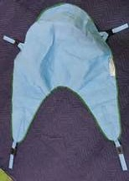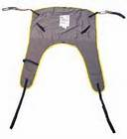
4 attachment points

Main back section

2 leg Sections

Sling without head support Sling with head support

General purpose slings are sufficient for the needs of between 85% and 90% of people.

NB If considering use for someone with a unilateral above knee amputation, please contact Moving and Handling Department for further guidance.

ii) Hammock style slings
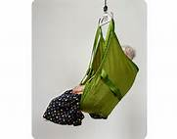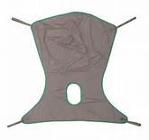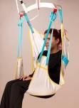

Provides appropriate support for people with lower muscle tone / poor trunk control / impaired sitting balance.

NB Sling requires to be fitted whilst person on a bed and requires to be left under the person when sitting on chair / wheelchair, therefore, ensure the person’s skin is not contraindicated for this sling.

iii) Amputee slings
Amputee slings are available in a range of styles including above & below knee and bi / unilateral to meet individual requirements
Provides appropriate support for people with lower limb amputation, particularly those with high above knee amputation.
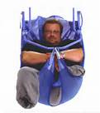

NB: Hammock slings can often be more suitable for this group.

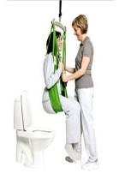iv) Toileting / Access / Hygiene Sling
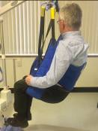

NB Person must have good muscle tone, sitting balance and compliance before considering this type of sling

v) Active / stand aid hoist slings
There are two main styles of active hoist slings - standing and transfer
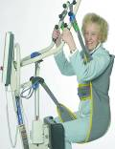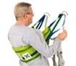

Standing Sling Transfer Sling

When using these slings the person should be encouraged to lean back into the sling to provide support while holding onto the hoist frame.
NB Standing sling – if a person is not sufficiently able to weight bear through their legs the sling will begin to move up under axillae with potential for body to slip through.
Transfer sling – the person should never be brought up into standing. This sling transfers the person in a sitting position.

vi) Walking and Standing slings
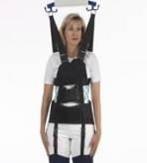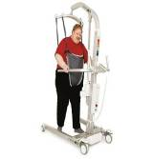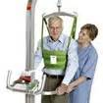

NB Due to the specific nature of these slings contact the Moving and Handling Department for further advice and guidance.

3) Fitting a sling to a person
3a) Choosing the size of a sling prior to working with the person for the first time is only an estimate. You must check during fitting that it is the correct size. This is done by:
In lying
- ensure the bottom of the sling is in line with the persons coccyx (tail bone)
- With the bottom of the sling at the persons coccyx, ensure that where the shoulder connection straps attach to the sling, this is level with the top of the persons shoulders. If it is not, the sling will be too large or small and should not be used
In sitting
- ensure the bottom of the sling is at the contact point of the persons buttocks and the base of the chair
- ensure that where the shoulder connection straps attach to the sling, this is level with the top of the persons shoulders. If it is not, the slings will be too large or small and should not be used

3b(i) Fitting a sling to a person lying in bed by turning and rolling the person
NB A minimum of two people to assist is required
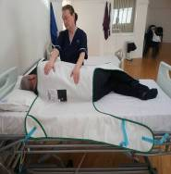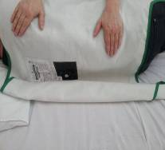

With the person on their side, one person assists them to stay there if required.  The second person places half of the sling (label facing away from the patient) along the length of the person’s back, ensuring the bottom of the sling is in line with the persons coccyx and the shoulder part of the sling is in line with the persons shoulder.  Drape the upper leg section over the persons thigh. | Roll the remaining side of the sling up towards the person’s back and  tuck under the person.
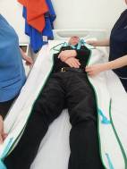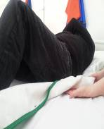

Allow the person to roll onto their back and unfurl the sling from underneath.
Check the sling is centrally placed under the person left and right.

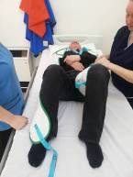
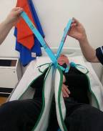
Pass the leg sections under and around the person’s thighs. If it is a ‘loop’ sling (as pictured), cross one leg section strap through the other and to the opposite sides. You do not need to do this with ‘clip’ slings

3b(ii) Fitting a sling to a person lying in bed using Slide Sheets
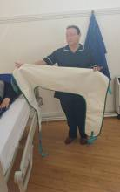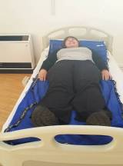NB A minimum of two people to assist is required
Insert two flat slide sheets below the person | Roll the back section of the sling up

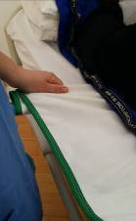Pass the leg section of the sling through between the two slide sheets at the person lower back and pull through the rolled up back section.
Unfurl the back section of the sling and slide into correct position, centred under the person with the lower edge of the back section at the persons coccyx and the shoulder section in line with the persons shoulders
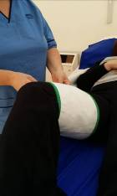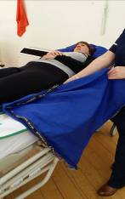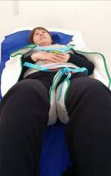

Remove top slide sheet
Position leg sections under and around the persons thighs
If it is a loop sling (as pictured), cross one leg section strap through the other and to the opposite sides.
Lastly profile the bed a little to raise the backrest and bend the knees prior to hoisting.

3c) Fitting a sling to a person sitting in a chair
NB A minimum of two people to assist is required
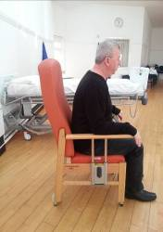

Encourage the person to sit forward in the chair, offering an appropriate level of support to achieve this if required | Slide the sling between the back of the chair and the person, ensuring the bottom edge of the back section meets the chair. Check the sling is the right size for the person – see section 3a.
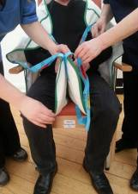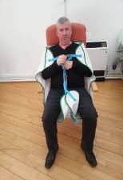
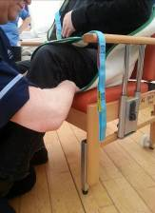

Position sling leg sections under and around the persons thigh. If it is a loop sling (as pictured), cross one leg section strap through the other and to the opposite sides.

4) Hoisting Activities
4a) Hoisting from bed using a mobile passive hoist
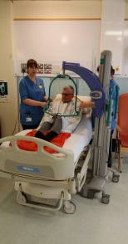NB: All hoisting activities must form part of the person’s individual moving and handling assessment plan and have a minimum of two people to assist involved.
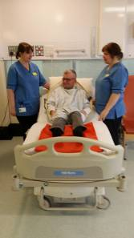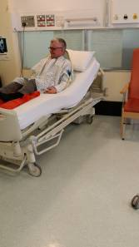

Fit sling using appropriate Create sufficient space Introduce hoist
method, by moving bed / furniture
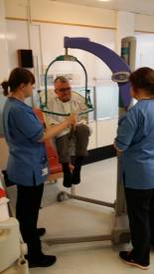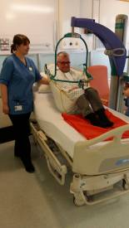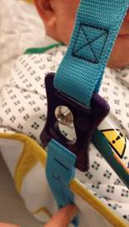

Raise hoist until sling is in tension, then check connections secure and the person is comfortable

Commence hoisting activity, ensuring one hander is in contact with the person at all times
Connect sling to hoist

4b) Hoisting from chair using an active hoist (Stand Aid)

NB: All hoisting activities must form part of the person’s individual moving and handling assessment plan and have a minimum of two people involved to assist

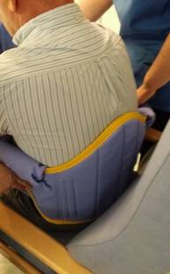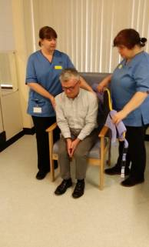

Encourage the person to sit forward in the chair, offering an appropriate level of support to achieve this if required

Insert sling behind person towards their lower back

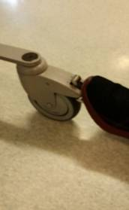
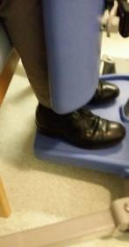

Fit waist strap and adjust Encourage person to place Only apply brakes if
until comfortable and their feet flat on the foot plate, assessed as required.
secure. assist if required.

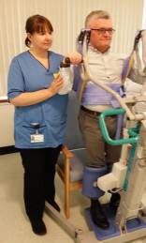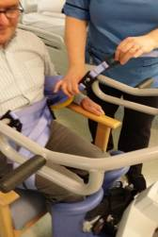

Attach sling to hoist Commence hoisting activity, ensuring
one person assisting is in contact with the
person at all times

- Overhead tracking hoist (OHT)
Most of the guidance in this document relating to passive mobile hoists is applicable to overhead tracking hoists as the slings and the spreader bars on the hoists are the same. Information relating to the return to charge and emergency stop features on some OHT’s is available here in the ‘video’ section.

