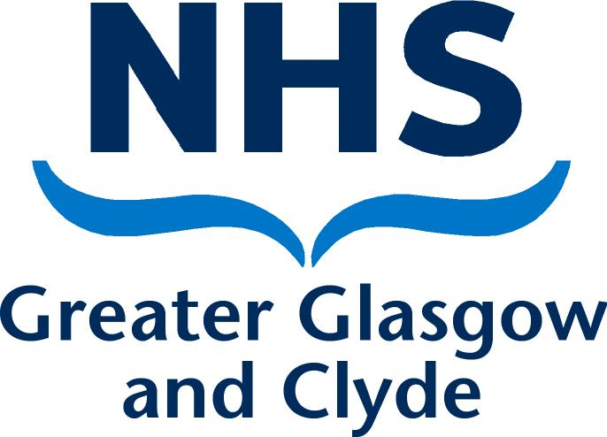

NHSGGC PROTOCOL FOR MANAGING CELEBRITY AND OTHER VISITORS

Purpose
NHS Greater Glasgow and Clyde (NHSGGC) regularly receives requests from individuals external to the organisation to visit our premises and services for publicity purposes and to make official openings.
We are supported by a number of charities and they too have a programme of regular events on NHSGGC premises which involve visits by celebrities and other VIPs.
As a public sector organisation we are publicly accountable and therefore regularly engage with politicians at all levels. As part of this scrutiny we receive regular requests from politicians to visit our services.
The purpose of this protocol is to provide clear guidance to staff on the arrangements to be followed when managing visits to NHSGGC premises.

Scope
This protocol applies to visits to premises directly owned and managed by NHSGGC. A separate protocol has been developed for health services provided within NHSGGC premises that are managed by the health and social care partnerships within our area.
Visits by the following are included within the scope of this protocol:
- celebrities;
- elected representatives, including Government Ministers, local, national and international politicians and councillors;
- members of the Royal Family
- official visits by charity partners and their ambassadors; and,
- other dignitaries.
For the remainder of this protocol these shall be referred to collectively as ‘VIP visitors’.
Visits outwith the scope of this protocol:
- visits by external organisations, including NHS Boards, professional exchanges and other visitors for business reasons; and,
- charity representatives granted permission to access NHSGGC premises for fundraising purposes.

Principles
All visits by VIP visitors must be authorised by the Chief Executive or Corporate Communications Directorate, including visits by individuals associated with charities.
Individual directorates/departments and charities must not invite VIP visitors into NHSGGC premises without first getting permission to do so.
All VIP visitors to be accompanied while on hospital premises (which serves to protect patients, the visitor and the hospital).
Visits must not interfere with the running of the service/hospital, disrupt patient care or compromise patient confidentiality.

Authorisation process
If you wish to arrange a visit to your service or if you receive a request from a VIP visitor to visit NHSGGC premises, including via charity organisations, you must notify this to the Corporate Communication Directorate at visits@ggc.scot.nhs.uk as soon as the request is received.
The Corporate Communications Directorate will liaise with the Chair, Chief Executive and Directors (or equivalent senior manager) as appropriate to:
- consider the appropriateness of the request;
- check the corporate diary to agree a suitable date;
- agree the level of representation to manage the visit; and,
- agree whether the visit is to be private or whether media can attend.
The Corporate Communications Directorate will then assess whether the visit should be managed as an official visit, a local visit or charity visitor.
As standard, all visits:
- should be hosted by a Director (or equivalent senior manager);
- must not place patients or vulnerable people at risk or breach patient confidentiality;
- will always be accompanied by NHS Greater Glasgow and Clyde or charity partner staff; and,
- should not take place during a patient’s treatment.
It is recommended that visits by VIPs are regarded as special occasions that are not repeated, except in specific circumstances such as the opening of facilities or commissioning of new equipment funded by the VIP.
A record of all VIP visits will be kept by the Corporate Communications Directorate.

Managing an authorised event
There are three categories of authorised visit - official visits, local visits and charity visits.
- Official visits include visits by Scottish Government Cabinet Secretaries, UK Government Ministers, Royal Visits, official openings and other events involving media access. These will be managed by the Corporate Communications Directorate, in consultation with Directors (or equivalent senior manager). This will include liaison with the relevant government departments, security and facilities arrangements and press handling. All media crews invited onto NHSGGC premises must be escorted at all times.

- Local visits will include private visits by overseas delegations and local politicians, including local authority councillors, Members of the Scottish Parliament (MSPs), Members of Parliament (MPs) and Members of the European Parliament (MEP). These can be managed by the Director (or equivalent senior manager). These visits must be private with no access by media.

- Charity visits will include visits by any dignitary who supports the work of the charity. The charity will be responsible for managing the event and media access but must agree the arrangements with the Corporate Communications Directorate before these can be finalised.
Individual directorates/departments and charities should only invite a VIP visitor onto NHSGGC premises once authorisation for the visit is received.
All programmes for a visit must ensure that the visitors are escorted at all times when on NHSGGC premises.

Official openings
Official openings should normally only take place three to six months after a facility has been operational to allow for bedding in of services.
Early discussion should take place to identify potential nominations to perform an official opening of the facility.
Requests for an official opening should be made to the Corporate Communications Directorate via visits@ggc.scot.nhs.uk who will liaise with the Chair and Chief Executive for agreement.
The Corporate Communications Directorate will manage official opening events including making an approach to a suitable dignitary to perform the opening ceremony.

Guidance during an election period
When an election is called, the Scottish Government Health and Social Care Directorates will issue specific guidance for NHS Boards and Special Health Bards about their role and conduct during the Election Period. This includes specific guidance on managing requests for visits to NHS premises at this time. This guidance should be adhered to in relation to any visits during the identified ‘Election Period’.

Review
This protocol will be reviewed periodically and not less than every three years.

Date: August 2017 – version 1.4

