Children and Young People's Specialist Services

Welcome to Skye House

West of Scotland
Adolescent Psychiatry
Inpatient Unit

Information for Young People, Parents and Carers

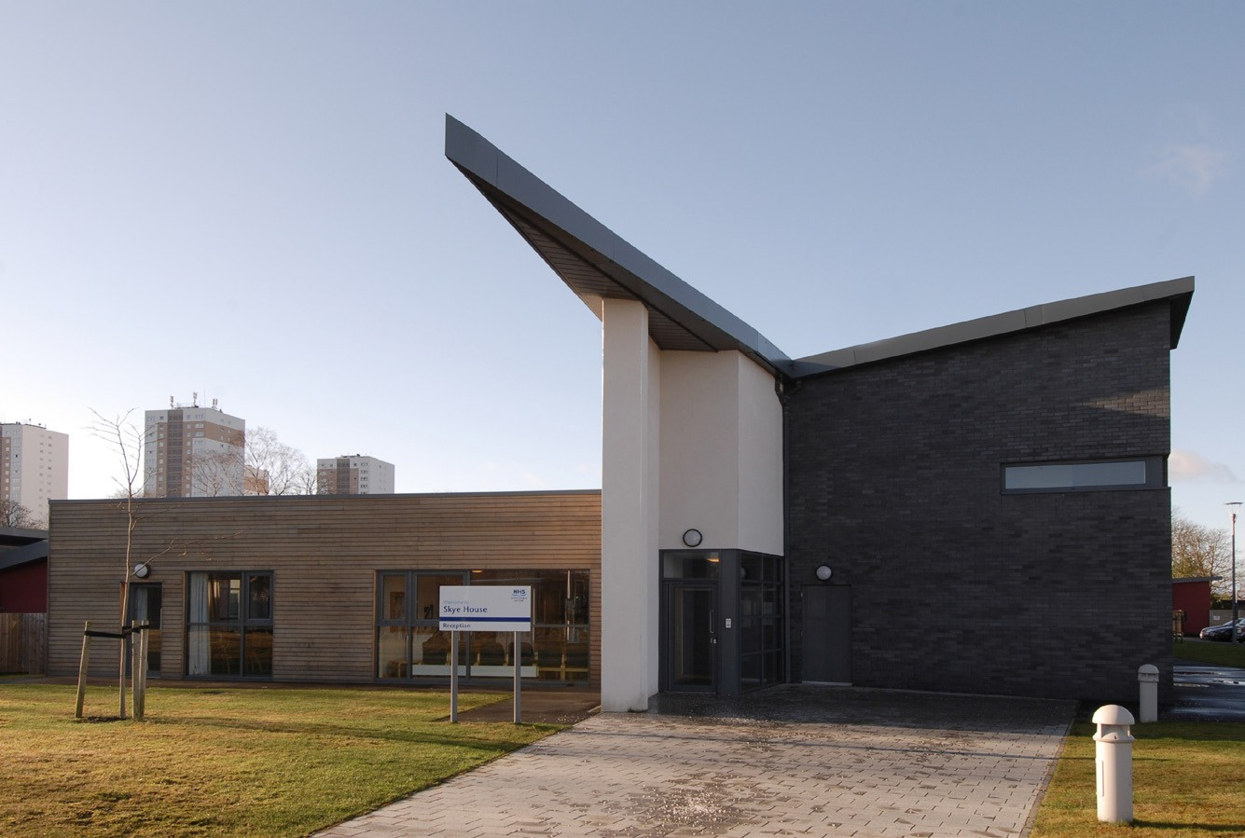

Skye House
Stobhill Hospital
133 Balornock Road, Glasgow G21 3UT Telephone 0141 232 6425 or 6420

Welcome to Skye House

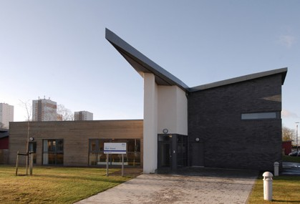
Skye House is based in Stobhill Hospital & is part of Child & Adolescent Mental Health Services (CAMHS).There is an accommodation block, a therapy block and a school.

Skye House helps young people between the ages of 12 and 17 who are having mental health difficulties and who require treatment in an inpatient unit.

They are having thoughts and feelings which make it difficult for them to cope with everyday life.

Coming into Skye House lets staff spend time getting to know you and to learn more about the things that are difficult for you like thoughts, feelings and how you behave.

You and your family will meet with staff to talk about what will happen during your stay.

All young people will go back home and get help and support from an out-patient team, or sometimes other services.

Getting better happens in a lot of different ways like:
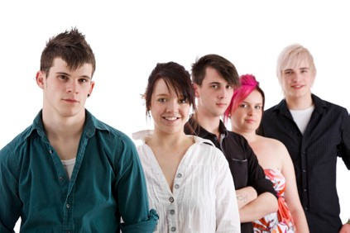
- Spending time with staff in individual sessions - this may be talking about your difficulties or doing something together…

- Learning new skills to help deal with difficult thoughts and feelings…

- Thinking about why you may have difficulties and finding ways to help you with them…

- All young people will have an agreed therapeutic programme and a care plan. You will be asked to sign your care plan by nursing staff.

- All young people will have prescribed treatments. This may include taking medication, talking treatments or activity programs.
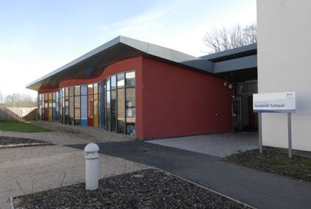
- When in Skye House all young people must attend school unless your doctor says you are too unwell to attend or you have treatments to attend during school hours.

What will happen in Skye House?

While you are in Skye House you will go to school, groups, and family meetings and have time with staff on your own. You will also have time to do things which you want to do.

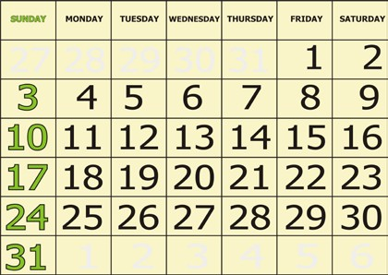
Weekly Timetable
Every week, you will get a timetable which tells you what is planned for you.

A day at Skye House

8 o’clock
- Get up…

- Have a shower…

- Get dressed…
- Have breakfast…

Next...
- Go to school, or

- Talk to staff, or

- Do an activity…

10 o'clock
- Join staff and peers for a mid-morning snack…

12 o’clock
- Have lunch…

3 o’clock
- School finishes.

- Afternoon snack….

5 o’clock
- Have dinner, then…

- Groups, or

- Free time…

At the weekend, you might get time away from Skye House to spend with your friends and family if you are well enough.

The nurses will still work with you at the weekend.

Bedtime Rules

  - Sunday ……..Half past ten
  - Monday .........Half past ten

  - Tuesday ..........Half past ten

  - Wednesday.....Half past ten

  - Thursday ........Half past ten

  - Friday .............12 o'clock/midnight
  - Saturday.........12 o'clock/midnight

The light will go off after you are in bed.

If you don't want your light off, you can keep the dimmed light on.

What can I bring when I come to stay at Skye House?

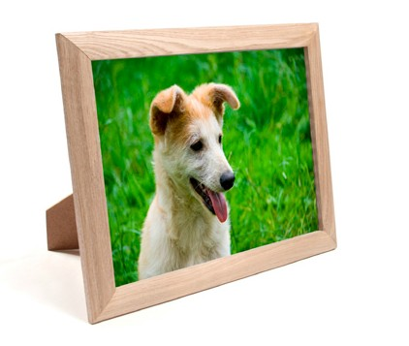
Staff will provide you with a list of appropriate items which you can bring into Skye House. This will be limited to help prevent infection. This may be different for each individual person. You will not be able to bring in your own bed clothing, duvet covers etc. This is to help prevent infection also.

You can bring things from home like photographs of family or pets.

Bring day and night clothes like jeans, jumpers, t-shirts, pyjamas, dressing gown and slippers. Also bring outdoor clothes like a waterproof jacket.

You should bring your school work and books with you.

TVs, laptops and DVD players are not allowed.

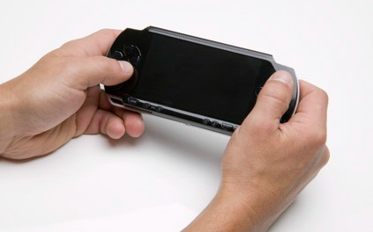
You can bring in hand held games or a MP3 player, but remember that the staff in Skye House will not be responsible for them.

You cannot bring anything with a camera. You cannot use your own phone if it has a camera or internet connection.

You may be supplied with a mobile phone by the ward. You will need to use your own SIM card for this.

When you are in Skye House, you are not able to smoke. Staff will not be able to take you out for a cigarette but they can offer you help to stop smoking.

What is there in Skye House?

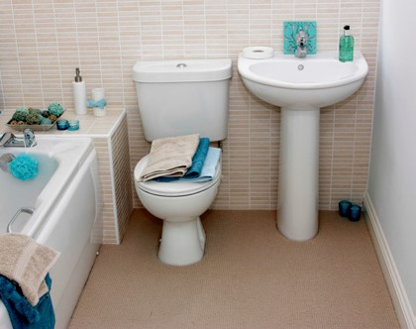
You have your own bedroom. You can use the white board in your room to personalise your room.

All the bedrooms have a bathroom which has a shower, a toilet and a sink. These may be locked at times.

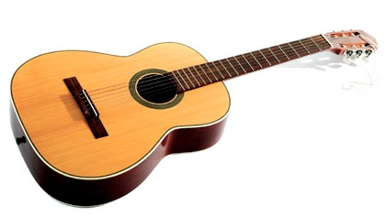
There is a lounge in each wing where you can watch TV and talk with other young people. Access to televisions and DVDs will be monitored in order to prevent improper use. These will not be available to you during school hours if you are well enough to attend school.

There is also a laundry room where you can wash and dry your own clothes if you want. Your family can take your clothes home to wash them if you want.
There is a music and games room. You can use this with staff.

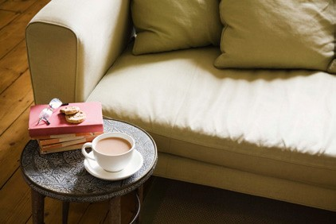
There is a gym which will be for young people and staff to use. You can also use the gym with family or friends.

There is a family room for visitors to use.

My rights while I am in Skye House

Patient’s Charter
This Charter is a leaflet which explains your rights when you are staying in Skye House. You can get a copy of the Charter from your Named Nurse.

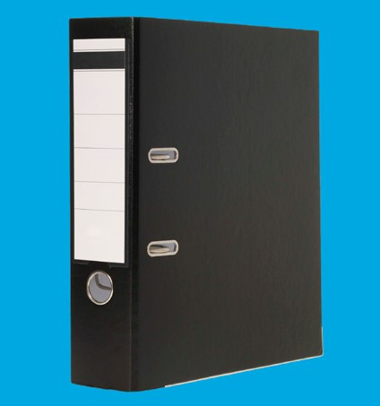
Reading your file
You might want to read your health notes. If you want to do this, please speak to your Named Nurse who will tell you how to do this.

Confidentiality
We will talk to your family doctor and the team who asked you to come into the unit. We will not be able to talk to anyone else, unless you say it is OK. We will tell you if we need to talk to other people. We may tell them important things which will keep you and other people safe.

Consent to Treatment
Many young people are happy to come and stay in Skye House, and can go home at any time if they want to.
Some young people who are very ill come in to Skye House under the Mental Health Act.

The Mental Health Act means that they must stay in Skye House and can only go out when their doctor says it is OK.
You will get a leaflet about this.

Page 9

School

If you are a school pupil you will go to Stobhill School.

School starts at 8.45 in the morning, and finishes at 3 o’clock in the afternoon.

You will have a timetable of appropriate classes. You can speak to any staff about this.

You can talk to the teachers about leaving school and going to college if you want.

You will have your own link teacher.

Page 10

Staff Members

There are a range of staff who work at Skye House including doctors, nurses, psychologists, occupational therapists, dietitians, family therapists, social worker, teachers, and speech & language therapists.

All young people will have a doctor and a named nurse.

Some young people will need to work with other team members.

Nurses
The nurses are in Skye House all the time. They can help with lots of things.

Each Young person in Skye House will have a ‘named nurse’ and an ‘associate nurse’. They are responsible for helping to support you.

One of these nurses will meet with you at different times each day. They will talk through any questions or problems that you might have.

Doctors
A Consultant Psychiatrist is a doctor who is specially trained to help you with the way you feel and behave. You will be allocated a consultant psychiatrist. Doctors will meet with you regularly to discuss your care.

Some young people will need to work with other team members.

You may be referred to other staff to help support you. If you are referred here are some of the staff who you may meet.

Occupational Therapists

They will support you in tasks and they will help you improve your skills.

Psychologists
They will work with you to help you understand and work on any difficulties you are having with your thoughts, feelings or behaviours.

Dietitian
The Dietitian will meet with you if you are in Skye House because of eating problems, or if you would like to talk about eating and drinking.

Social Worker
The Social Worker thinks about how you are getting on in Skye House and at home. Social workers are there to look after your safety and well being.

Speech and Language Therapists
The Speech and Language Therapist helps young people with language and communication problems and eating and swallowing problems.

Teachers
The classes in Stobhill School are small, so it is easy to talk to the teachers.

Family Therapists
Family Therapists work with young people and their family. They support a young person to get better and return home

Physiotherapists
The Physiotherapist helps young people with exercise and movement.

Observations

While you are in Skye House you might need close observation from nursing staff.

There are different kinds of observations:

General Observations
This means that staff should know where you are at all times. This is for all young people in Skye House.

Constant Observations
This means that a nurse will always be able to see your or hear you.

Special Observations
This means that there will be a nurse beside you all the time.

You will not have to be on 'Special Observations' or 'Constant Observations' all the time. This will stop when you don’t require it.

Most young people will never require special or constant observations.

Page 13

Meetings

There are different types of meetings in Skye House:

Early Care Planning Meeting
There will be an early care planning meeting arranged within 10 days of your admission to Skye House. You and your parents or carers can attend this. The goals of your admission will be discussed and agreed at the meeting.

Weekly Clinical Meeting
This meeting is where staff talk about how you are getting on in Skye House. You will be told what has happened in these meetings and about any decisions that have been made. You will also be able to talk about any wishes you have about your care with your named nurse and your views will be taken to the meeting.

Review Meeting
A review is a meeting about you. There will be staff from Skye House at this meeting. There are other people from outside as well, like teachers from your school or your social worker. You and your family can come to the meeting and can tell people at the meeting how you feel and what you think. You will be asked to consent to other people attending this meeting. If you do not want other people for example schoolteachers, social workers or even parents then they may not be able to attend

Discharge Planning Meeting
Discharge planning will start prior to or at the time of admission. An initial discharge date will be set at 28 days from the date of your admission. This meeting will discuss and agree plans for your discharge from Skye House and your care and treatment by teams in the community following your discharge.
Page 14

If you are unhappy with the Service, the staff or Skye House

Please talk to a member of staff if you are not happy with our service. They will listen to what you have to say and make sure you get a reply.

If you are not happy with the reply you get, you can speak to the Senior Charge Nurse.

Partners in Advocacy
This is an independent organisation that will help you to speak up about what you think. They will stick up for you and make sure people listen to what you say.

There will be posters in Skye House that tell you when Partners in Advocacy will be coming to Skye House, so you can decide if you would like to meet and talk with them.

Mental Welfare Commission for Scotland
This is an independent organisation that protects your rights if you are getting help for mental health difficulties. The Mental Welfare Commission can give a second opinion. They can also look at any concerns, worries or complaints you have about your care in Skye House.

Their address and phone number is:
Mental Welfare Commission for Scotland
Thistle House
91 Haymarket Street
Edinburgh
EH12 5HE
Telephone 0131 313 8777

Designed and Produced by Medical Illustration Services Ref 248461

Page 15

The Senior Charge Nurse is:

………………………………………

Your Consultant is:

……………………………………………………

Your Named Nurse is:

……………………………………………….

Your Associate Nurse is:

……………………………………………

Your Case Manager is:

………………………………………………

