Department Name
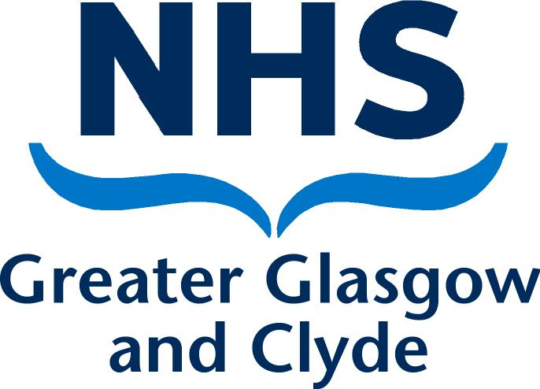
Directorate
Address 1
Address 2
Address 3
Post Code

PRIVATE & CONFIDENTIAL
NAME  ADDRESS1  ADDRESS2  ADDRESS3  POST CODE | Date: DATE  Ref No:  Direct Line: Number  Email:  Contact: NAME
Dear [name]

Outcome of Formal Stage 2 Capability Mid Review Meeting

I write to confirm the outcome of the Formal Stage 2 Capability Mid Review Meeting that was held on [date] in [location]. The meeting was held in accordance NHS Greater Glasgow and Clyde’s Employee Capability Policy and Procedure.

You attended with [name of person representing / accompanying the employee & name of organisation if relevant] OR: [You attended on your own and confirmed at the beginning of the hearing that you wished to go ahead without representation.] [HR name and job title] was also in attendance

At the meeting we discussed the following performance issues: -
[summary of capability issues]

The purpose of the meeting was to review your performance during the Formal Stage 2 Capability process and to provide constructive feedback. Furthermore, the meeting is to allow you an opportunity to feedback.

[detail feedback to employee and employees own feedback and any further actions agreed]

A Final Review Meeting will be arranged within [timescale]. A letter will be sent to you separately to confirm the arrangements for this meeting.

I must advise that if progress is not satisfactory, I may have to take the decision to refer the matter to the NHS Greater Glasgow and Clyde’s Disciplinary Policy and Procedure in accordance with NHS Greater Glasgow and Clyde’s Employee Capability Policy and Procedure. One potential outcome of this referral to the Disciplinary Policy may be consideration of the termination of your employment.

Can you please review the content of this letter and sign and return a copy to me if you are in agreement that the letter accurately reflects the content of the meeting. If you feel there are any inaccuracies, then please advise me of these in writing within 5 working days of receiving this letter. If you fail to return a signed copy of this letter or advise me of any inaccuracies within 5 working days, it will be assumed that you accept the document as an accurate account of the meeting.

In the meantime, if you have any queries please do not hesitate to contact me on [phone number].

Yours sincerely

[Managers Name]
[Job Title]
[Service]

-----------------------------------------------------------------------------------------------------------------

Acknowledgement Form

I, [employee name], confirm that I have received the letter dated [date] and understand all of the contents of this letter. I also agree that the letter details an accurate reflection of what was discussed at the meeting.

Signed:…………………………………………………………….. Date………………………..

Please sign and return one copy of this letter to me within 5 working days. A copy will be placed in your personal file

