Department Name
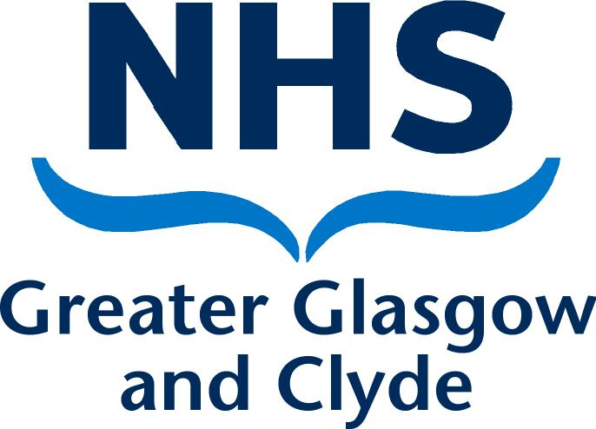
Directorate
Address 1
Address 2
Address 3
Post Code

PRIVATE & CONFIDENTIAL
NAME  ADDRESS1  ADDRESS2  ADDRESS3  POST CODE | Date: DATE  Ref No:  Direct Line: Number  Email:  Contact: NAME
Dear [name]

Informal Capability Meeting Outcome

I write to confirm the outcome of the Informal Capability Meeting that was held on [date] in [location]. The meeting was held in accordance with NHS Greater Glasgow and Clyde’s Employee Capability Policy and Procedure (attached for reference). The following individuals were present at the meeting [details].

The purpose of the informal capability meeting was to discuss the areas of improvement required to be completed and to agree a reasonable timeframe for this.

At the meeting we discussed the following issues:
[Include:
- Details of the issues discussed
- The agreements reached
- The timescales during which satisfactory improvement is expected to be reached and maintained.]

The purpose of this letter is to advise you of the outcome of the informal meeting and the next stage of the process.

We agreed performance targets and an action plan (enclosed). I will monitor your progress towards meeting these targets over the next [timescale] and will provide the support as outlined in the action plan to facilitate your improvement.

A Final Review Meeting will be arranged to review your progress during the informal capability stage and I will write to you in due course to confirm the details for this meeting. I must advise that if the required improvements and performance targets are not achieved, in accordance with the Board’s Employee Capability Policy and Procedure, it may be necessary to progress to Formal Stage 1 of the Capability procedure.

Can you please review the content of this letter and sign and return a copy to me if you are in agreement that the letter accurately reflects the content of the meeting. If you feel there are any inaccuracies, then please advise me of these in writing within 5 working days of receiving this letter. If you fail to return a signed copy of this letter or advise me of any inaccuracies within 5 working days, it will be assumed that you accept the document as an accurate account of the meeting.

In the meantime, if you have any queries please do not hesitate to contact me on [phone number].

Yours sincerely

[Managers Name]
[Job Title]
[Service]

-----------------------------------------------------------------------------------------------------------------

Acknowledgement Form

I, [employee name], confirm that I have received the letter dated [date] and understand all of the contents of this letter. I also agree that the letter details an accurate reflection of what was discussed at the meeting.

Signed:…………………………………………………………….. Date………………………..

Please sign and return one copy of this letter to me within 5 working days. A copy will be placed in your personal file

