What is a PDSA
The Plan-Do-Study-Act method is a way to test a change that is implemented. By going through the prescribed four steps, it guides the thinking process into breaking down the task into steps and then evaluating the outcome, improving on it, and testing again. Most of us go through some or all of these steps when we implement change in our lives, and we don’t even think about it. Having them written down often helps people focus and learn more.
Keep the following in mind when using the PDSA cycles to implement E-ess and its changes to the way people work.
- Single Step - Each PDSA often contains only single step of the entire implementation.
- Short Duration - Each PDSA cycle should be as brief as possible for you to gain knowledge that it is working or not (some can be as short as 1 hour).
- Small Sample Size - A PDSA will likely involve only a smaller part of the department or function. Once that feedback is obtained and the process refined, the implementation can be broadened to include wider groups.
Why use a PDSA?
You may not get the results you expect when making changes to your processes, so it is safer, and more effective to test out improvements on a small scale before implementing them across the board.
Using PDSA cycles enables you to test out changes before wider implementation and gives stakeholders the opportunity to see if the proposed change will work.
As with any change, ownership is key to implementing the improvement successfully. If you involve a range of colleagues in trying something out on a small scale before it is fully operational, you will reduce the barriers to change.
How to test:
- Plan multiple cycles to test how ideas will work in practice.
- Test on a really small scale. For example, start with one element of the system
- Test the proposed change with people who are supportive of the change process. Don't try to convert people into accepting the change at this stage
- Only implement the idea when you're confident you have considered and tested all the possible ways of achieving the change
How to use it
The model (figure 1 below) is based in scientific method and moderates the impulse to take immediate action with the wisdom of careful study. The framework includes three key questions and a process for testing change ideas.
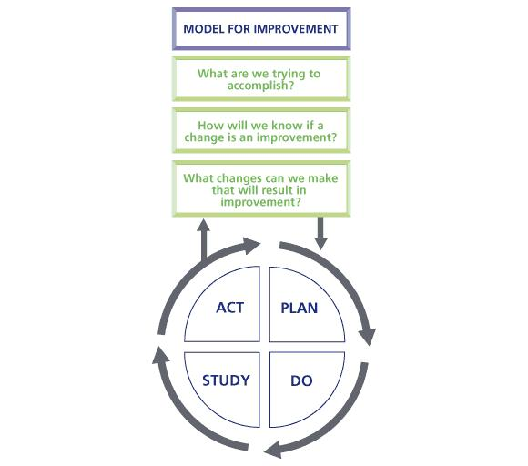
Figure 1
What we trying to accomplish?
Teams need to set clear and focused goals. These goals require leadership and should focus on problems that cause concern.
The aims statement should:
• Be relevant to the length of the project
• Be bold in its aspirations
• Have clear, measurable targets

How do we know if the change is an improvement?
You will need to measure outcomes, such as reduction in the time a process takes. If we make a change, this should affect the measures and demonstrate over time whether the change has led to sustainable improvement. The measures in this model are tools for learning and demonstrating improvement, not for judgment.
Each project team should collect data to demonstrate whether changes result in improvement.
You should report improvement progress monthly on time series graphs known as ‘run charts' or statistical process control charts (SPC). See the PJA.

What changes can we make that will result in improvement?
There are many potential changes a team could make. However, evidence from scientific literature and previous improvement programmes suggests that there are a small number of changes that are most likely to result in improvement.
It is possible that there may be several PDSA cycles running sequentially (figure 2), or even simultaneously (figure 3). Sequential cycles are common when the study reveals results which suggest a different approach is needed
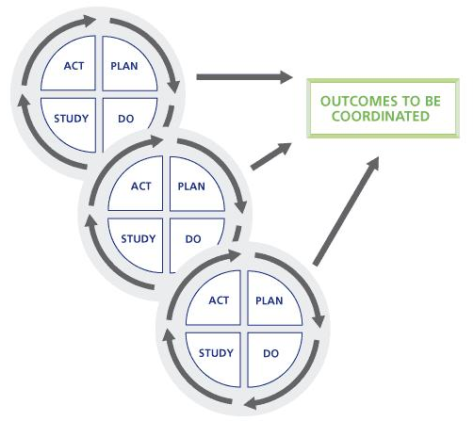
Figure 3
Figure 2
Simultaneous cycles may occur when the changes are more complex, possibly involving several departments. It is important that you identify any interactions between simultaneous cycles, as a change in method in one cycle may alter the impact of another somewhere else. For example, you are making changes to the way that secretaries process letters, so that they are printed and stuffed into envelopes in a central department. As another part of the project, a PDSA cycle looks at when doctors sign their correspondence and concludes that is should be done in the secretary's office. Obviously the two solutions conflict.

