**BUILDING TRUST**

**What is it and how can it help me?**

**What is trust?**If you want someone to trust you, they need to believe that you are both competent, and that you care about them. As demonstrated in the model below, competency without caring may engender respect, but not trust. On the other hand, if someone is seen as caring but incompetent, they may not be trusted to do the job in hand.

**Building trust:**

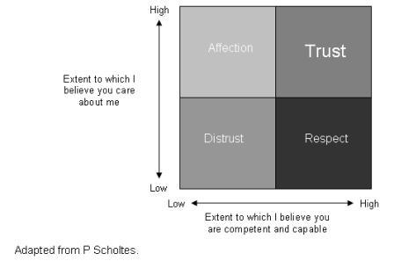

**Trust and relationships:**   
You can encourage people to trust you if you:

* Do what you say you will - don't make promises you can't keep
* Listen carefully and tell people what you think they are saying so they know you understand them
* Understand what matters to people
* Bear in mind people's best interests

**You can encourage good relationships with people if you:**

* Are able to talk to each other and are willing to listen
* Show respect in ways that people want
* Understand and respect their values and beliefs
* Are honest and do not hide your shortcomings
* Remember that trust does not automatically come with friendship
* Tell the truth!

**When does it work best?**

Building trust is key to gaining ‘buy in' from your team and encouraging them to work with you to make the changes needed to improve processes and systems. This way, you are all working together towards the same goal.

You can use this approach in any management situation. If your focus is to build staff's trust in you as a manager or a project manager for an improvement project, you may want to use some of these tips as you go along.

**How to use it**

This tool helps you gain support from your team as you implement the changes necessary. If your team trusts you and people feel comfortable with the impact of change, they are more likely to work with you in making improvements.

**Other useful tools and techniques on this website:**The [art of listening](http://www.institute.nhs.uk/quality_and_service_improvement_tools/quality_and_service_improvement_tools/listening_-_importance_of_this_skill.html) is a valuable technique that will aid you in building trust.   
Having a team that trust you will help you overcome [human barriers to change](http://www.institute.nhs.uk/quality_and_service_improvement_tools/quality_and_service_improvement_tools/human_dimensions_-_human_barriers_to_change.html).