NHSGGC Leadership Academy

NHS Glasgow and Clyde Leadership Academy is a designed collaborative learning environment that mirrors the community network used by Managers in their day-to-day work and learning. People looking for the primary source of advice, methods, leading practices, and lessons learned tend to create local informal networks of colleagues and in turn, contribute to these informal networks.

People who share their expertise are more likely to receive feedback and ideas from other people. This feedback might help the individual to more quickly and more effectively shape, grow, and refine their knowledge and skills. Sharing expertise might also lead to new connections, and this might reduce the time it takes to find leading practices, validate new ideas, and get advice.

The online facility is guided learning, a body of knowledge, a reference tool, personal feedback and exchange zone all in one.
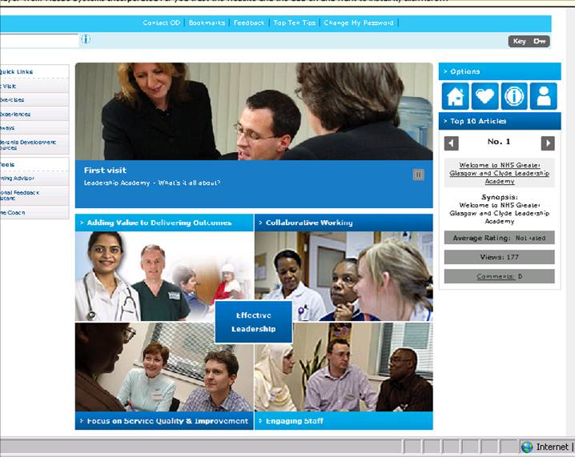

How to Access the On-line Academy
- To access the Academy please discuss with your local OD adviser in the first instance who can provide more information
- You may be offered a licence to use the Academy as part of your participation in a leadership development programme eg Ready to Lead
Designed specifically for Managers who want to exchange and develop a deeper understanding of management thoughts, the Academy is structured to meet the needs of Managers with only a few minutes to use a top ten tip and for Managers who enjoy thought provoking articles to inspire learning and consolidate previous learning.

- The approach recognises the diversity of managers across NHSGGC. Whatever their development needs, this package has been designed to offer something for everyone:

Often Managers are inundated with requests for feedback on top of everything else. You can quickly rate and comment briefly on content and request content to be added to address specific needs. Your feedback is used to integrate articles and exercises to evolve the design with the varied approaches Managers use to develop skills, knowledge and teams. For this reason, feedback is encouraged from everyone using the Academy.

There are various starting points depending on how you prefer to learn, beginning with A First Visit. In this section you will find a Learning Advisor to determine your preferred learning style and the optimum approach to using the Academy. Learning Advisor analyses your preferred learning style in just 9 sets of responses. The results from this 5 minute exercise will help you use the Academy’s vast volume of articles and exercises in the way that suits you best.

Experiment and explore
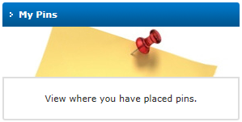
Exploring is a second useful step as there are many elements and resources that exist within the Academy. Start anywhere and follow the links. Pin the articles and content that appeal to you so that you can come back to them at any time using My Profile, My Activity, My Pins. Enjoy it and make it your own.

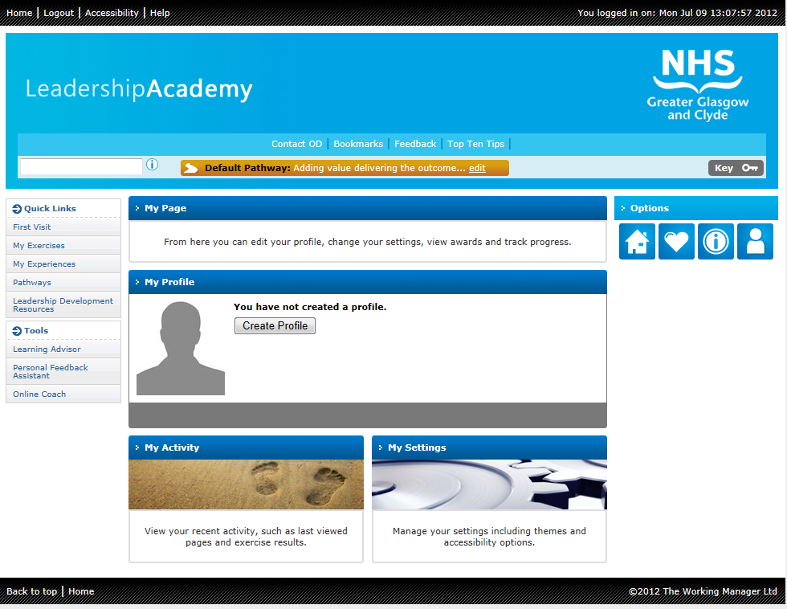
Sample screenshots to explore
My Profile
My Activity

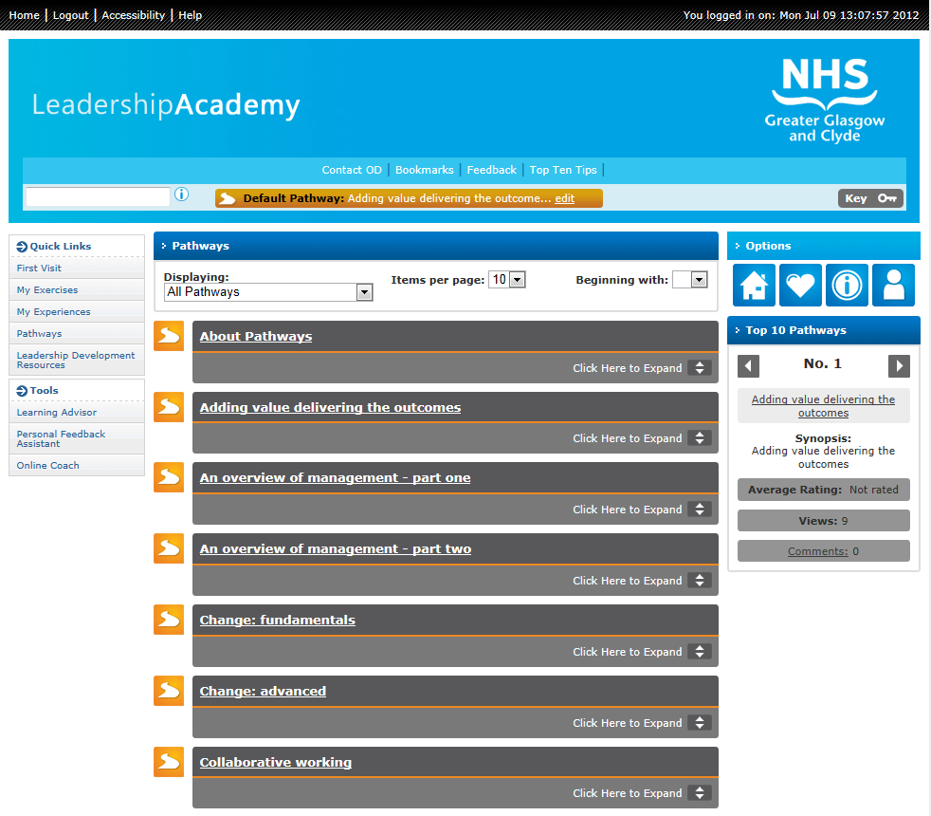
Pathways
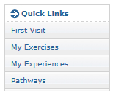

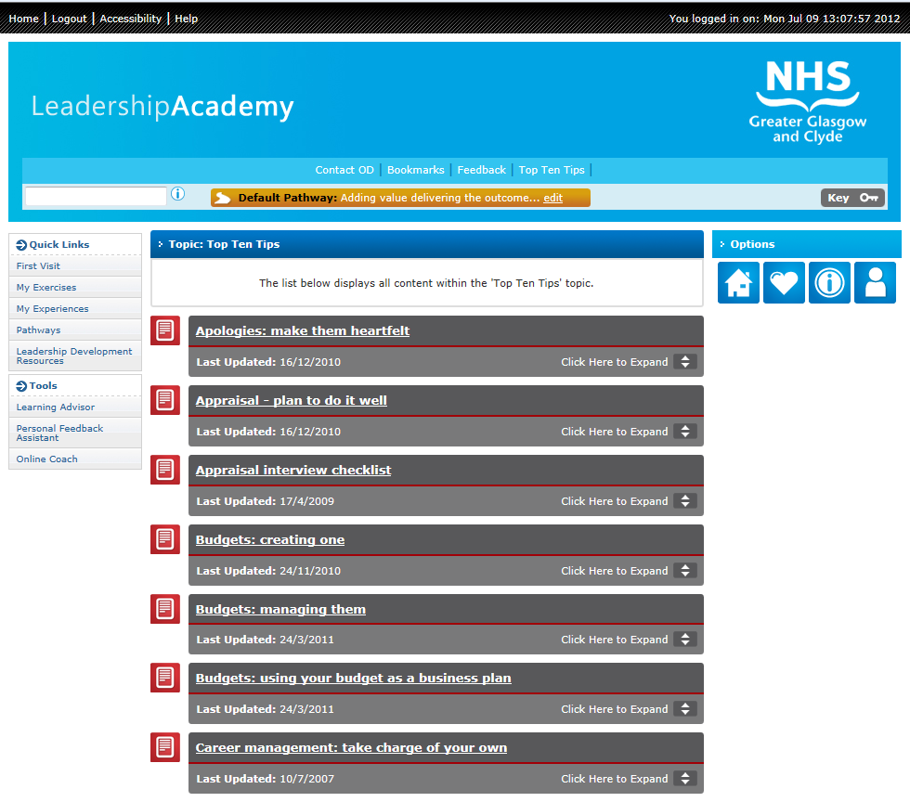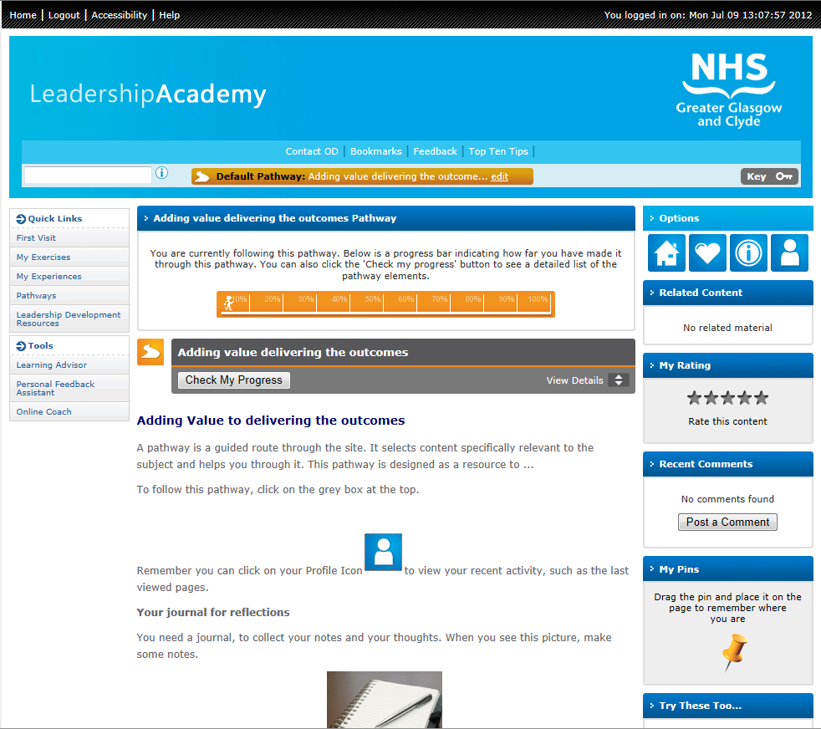
Top Ten Tips

It's the links that do the work
The links are there to show you explanatory material, to give you ideas, to bring in material relevant to your current interest, to provoke thoughts about other aspects and generally, to offer you alternative routes through the Academy.

Exchange opinions and thoughts by rating and commenting on content

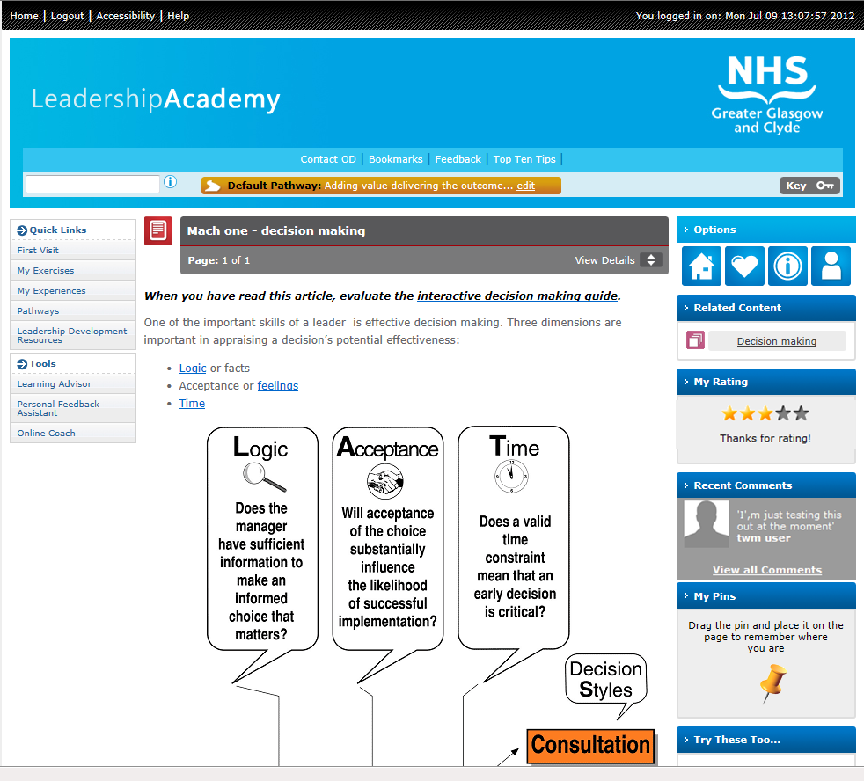
Rate an Article or Pathway
Comment on an Article or Pathway
Pin content within an Article or Pathway to return to later

